Cluster Analysis

Clustering - Given a set of data points, partition them into groups containing very similar data points.

Cluster analysis is a data analysis technique that groups items into clusters so that items within the same cluster are more similar to each other than to items in other clusters.
It’s an unsupervised learning method—meaning there are no predefined labels; the structure is discovered from the data itself.

Applications of Cluster Analysis

Data Summarization
- Groups large datasets into a small number of representative clusters
- Provides a concise overview of complex data
- Often used as the first step in data mining processes
- Helps reveal hidden patterns and structures

Customer Segmentation
- Identifies groups of customers with similar behaviors or preferences
- Enables targeted marketing and personalized services
- Used in collaborative filtering for product recommendations
- Improves customer understanding and business decision-making

Social Network Analysis
- Detects communities of closely connected nodes
- Reveals groups of friends or social communities
- Helps analyze community structure and group dynamics
- Useful for understanding social behavior patterns

Relationship to Other Data Mining Problems
- Provides summarized data representations
- Used as a preprocessing step for classification models
- Aids in outlier and anomaly detection
- Improves efficiency and effectiveness of other mining tasks

Feature Selection in Cluster Analysis
- Many datasets contain noisy or irrelevant features
- Such features can distort similarity measurements
- Noisy features may hide true cluster structures
- Feature selection aims to identify and remove uninformative features
- Performed early in the clustering process
- Improves accuracy, efficiency, and interpretability of clusters

Why Feature Selection Matters
- Reduces computational cost
- Enhances cluster quality
- Prevents misleading clustering results

Feature Selection for Clustering

- Goal: Remove noisy or uninformative features that do not cluster well
- More difficult in unsupervised learning because:
  - No class labels or external validation criteria
- Closely related to clustering tendency of features
- Objective: select feature subsets that maximize inherent cluster structure
- Improves:
  - Cluster quality
  - Interpretability
  - Computational efficiency

Models for Feature Selection

Filter Models
- Assign a score to each feature using similarity-based criteria
- Features below a threshold are discarded
- Can evaluate:
  - Individual features, or
  - Feature subsets (captures interaction effects)
- Advantages:
  - Fast and scalable
  - Performed as a preprocessing step
- Limitation:
  - Independent of the clustering algorithm

Wrapper Models
- Use a clustering algorithm to evaluate feature subsets
- Feature selection and clustering are iterative and interdependent
- Optimizes features for a specific clustering method
- Advantages:
  - Can produce better clustering results
- Limitations:
  - Computationally expensive
  - Results may depend on the chosen clustering algorithm
  - Feature importance may be biased by the clustering method

Key Difference
- Filter models: preprocessing-based, algorithm-independent
- Wrapper models: integrated into clustering, algorithm-dependent

Filter Model Methods for Feature Selection
Filter models evaluate features independently of any clustering algorithm, using statistical or similarity-based criteria to estimate how useful a feature is for revealing cluster structure.

1. Term Strength
Concept
Term Strength measures how consistently a feature (term/attribute) appears among similar data points.

Notation
- Let xi be a data point
- Let NN(xi)be its nearest neighbor
- Let f be a feature (term)

Formula
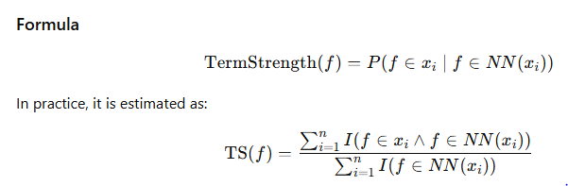Where:
- I(⋅)is an indicator function (1 if true, 0 otherwise)
- n is the number of data points

Interpretation
- High term strength → feature is shared among similar points → good clustering feature
- Low term strength → feature appears randomly → noisy or uninformative
How it works
- Identify nearest neighbors for each data point
- For a given feature:
  - Check whether it appears in both a data point and its neighbors
- Term strength is the probability that a feature occurs in similar points
Advantages
- Simple and intuitive
- Effective for text and high-dimensional data
Limitations
- Depends on the quality of similarity measures
- Sensitive to nearest-neighbor selection

2. Predictive Attribute Dependence (PAD)
Concept
Predictive Attribute Dependence evaluates how well a feature can predict other features in the dataset.
How it works
- Measure statistical dependence between attributes
- A feature is useful if:
  - It has high dependence with a subset of attributes
  - Indicates structured relationships rather than randomness
Measures how well one feature predicts or depends on other features.

Common Measure
Mutual Information (MI) is typically used.
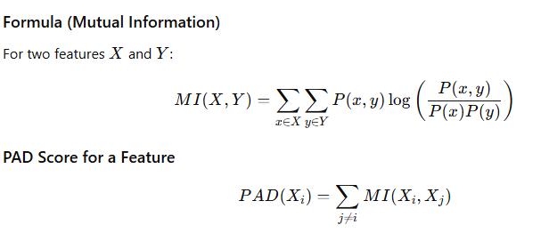

Interpretation
- High PAD → feature has strong dependence with others,captures meaningful data relationships
- Low PAD → feature is independent and less informative, likely noise
Advantages
- Captures attribute interactions
- Useful when clusters are defined by correlated features
Limitations
- Computationally expensive for large datasets
- May overlook features useful only in combination

3. Entropy-Based Feature Selection
Concept
Entropy measures the uncertainty or randomness of a feature.
How it works
- Compute entropy for each feature:
  - High entropy → values evenly distributed → less informative
  - Low entropy → values concentrated → more discriminative
- Features with lower entropy are preferred
Entropy measures the uncertainty or randomness of a feature.
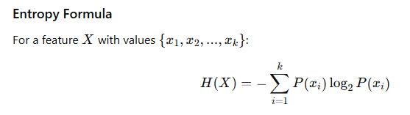Where:
- P(xi) is the probability of value xi

Selection Criterion
- Features with lower entropy are preferred

Interpretation
- Low entropy → concentrated values → good clustering potential
- High entropy → uniform distribution → noisy feature
Advantages
- Strong theoretical foundation (information theory)
- Easy to compute
Limitations
- Low entropy does not always guarantee good clustering
- Ignores relationships between features

4. Hopkins Statistic
Concept
Hopkins Statistic measures the clustering tendency of a feature or feature subset.
How it works
- Randomly sample points from the dataset
- Generate uniformly random points in the same space
- Compute distances:
  - Between sampled data points and nearest neighbors
  - Between random points and nearest neighbors
- Compare these distances to compute the Hopkins value
Measures the clustering tendency of data or a feature subset.

Notation
- m: number of sampled points
- xi​: random point
- yi​: real data point
- ui​: distance from xi​ to nearest real data point
- wi: distance from y​ to its nearest neighbor
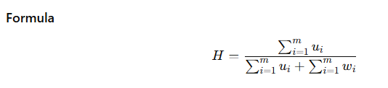
Interpretation
- Hopkins value ≈ 0.5 → random distribution (poor clustering)
- Hopkins value → 1 → strong clustering tendency
- Features with higher Hopkins values are selected
Advantages
- Directly measures clusterability
- Independent of clustering algorithm
Limitations
- Sensitive to distance metrics
- Computationally intensive for large dataset

Method | Measures | Key Idea
Term Strength | Feature consistency | Shared among similar points
Predictive Attribute Dependence | Attribute dependence | Predicts other attributes
Entropy | Uncertainty | Low randomness preferred
Hopkins Statistic | Cluster tendency | Measures data clusterability

Wrapper Models

Basic Idea
- Wrapper models perform feature selection by directly using a clustering algorithm together with an internal cluster validity criterion.
- Instead of evaluating features independently, wrapper models assess how well a subset of features performs in producing good clusters.
- Validity criteria measure clustering quality (e.g., compactness, separation)

Use of Cluster Validity Criteria
- A clustering algorithm is applied to a subset of features
- The resulting clustering is evaluated using a cluster validity criterion
- The feature subset that maximizes clustering quality is preferred

Search over Feature Subsets
- The number of possible feature subsets grows exponentially with dimensionality
- Exhaustive search is infeasible for high-dimensional data
- Therefore, greedy search strategies are often used:
  - Start with all features
  - Iteratively remove the feature whose removal leads to the largest improvement in cluster validity

Drawbacks of Validity-Based Wrapper Models
- Highly sensitive to the choice of cluster validity criterion
- Cluster validity indices are imperfect and heuristic-based
- Computationally expensive, since clustering is repeatedly performed
- May not scale well to large or high-dimensional datasets

Wrapper Models Using Supervised Feature Criteria

Key Idea
A simpler wrapper approach borrows feature selection criteria from classification, even though clustering is unsupervised.

Artificial Label Creation
- A clustering algorithm is first applied
- Cluster identifiers are treated as artificial class labels L

Two-Step Procedure

Step 1: Clustering
- Apply a clustering algorithm on the current feature subset F
- Assign cluster labels L to all data points

Step 2: Feature Evaluation
- Treat labels L as class labels
- Use supervised feature selection criteria to evaluate features individually
- Select the top-k most discriminative features

Supervised Criteria Commonly Used
- Class-based entropy
- Fisher score
  - Measures the ratio of intercluster variance to intracluster variance
  - High Fisher score → feature strongly separates clusters

Iterative Extension of the Two-Step Method
- Instead of hard feature selection:
  - Top-k features are assigned weight = 1
  - Remaining features are assigned weight = α < 1
- Clustering is repeated using weighted features
- Final selection chooses the top-k features
- Allows gradual refinement of feature importance

Hybrid Models (Filter + Wrapper)

Motivation
- Wrapper models are accurate but expensive
- Filter models are fast but less precise

Hybrid Approach
- Use filter models to generate candidate feature subsets
- Evaluate each subset using:
  - A clustering algorithm with a validity criterion, or
  - A classification algorithm on generated cluster labels
- Select the best-performing subset

Advantages
- More accurate than pure filter models
- More efficient than pure wrapper models
- Good trade-off between performance and computational cost

